Name ______________________________
Unit II: 600-1450
The Big Picture: Themes of AP WH
- Development and interaction of cultures (In other words: WHAT HAPPENS WHEN PEOPLE COME IN CONTACT WITH EACH OTHER?
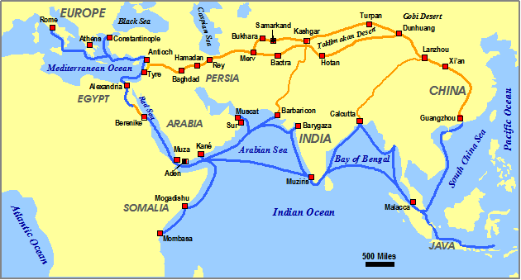
This time period witnessed tremendous growth in long-distance trade through the Silk Road, the Indian Ocean, Trans-Saharan trade, and the Mediterranean Sea. During the period of ______________________, when peace and order was established due to the _______________________________, trade and interaction were at their height.
- The dynamics of change and continuity across world history periods covered in this course, and the causes and the processes involved in major changes of these dynamics. (In other words: WHY DO SOME THINGS CHANGE WHILE OTHERS STAY THE SAME?”
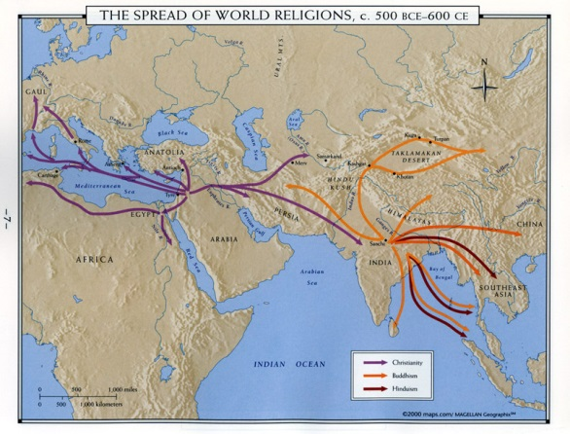
Changes Continuities

- The effects of technology and economics on people and the environment. (In other words: HOW DOES THE DEVELOPMENT OF NEW TECHNOLOGY AND MOVEMENT OF PEOPLE EFFECT THE WORLD?)
Technological developments: _______________, improved ship building technology, and _________________.
Movement of people including the _______________________________________ greatly altered the world.
One of the most epidemic diseases in history, the Bubonic Plague/Black Death, spread during this period due the _________________________________________________________________
- Development and transformation of social structures In other words: HOW DO SOCIETIES ORGANIZE THEMSELVES SOCIALLY, AND WHAT ROLES DO MEN AND WOMEN PLAY?
Although most societies continued to reinforce their ______________________nature and strict __________________, the spread __________________________ religions had some effects. Religions such as Islam, Christianity, and Buddhism preached the _____________________________ and this seemed to be the case ,at least in a spiritual sense.
- Cultural, intellectual, and religious developments and interactions among and within societies. (In other words, HOW DO PEOPLE IDENITFY THEMELVES AND EXPRESS THEMSELVES CULTURALLY AND INTELLECTUALLY?
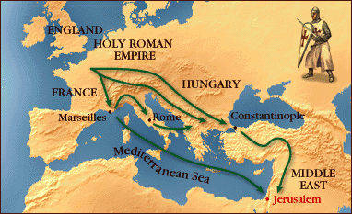
The spread of _____________ during this time period often acted as a _________________________ force. For example, Christianity and the Church served as the __________________________force in Western Europe during most of this period. Also, the spread of Confucianism and Buddhism throughout East Asia solidified a _______________________ in those areas. The new religion of Islam created a new cultural world known as the ___________________________which _________________________ political boundaries.
- State-building, expansion, and conflict (In other words: HOW DO PEOPLE GOVERN THEMSELVES?)
Following the fall of the classical empires, the political structures of many areas _________________________________________ to the new conditions of the world. ____________ empires like the Byzantine, ________________________, and the Tang and Song Dynasties built off the successful models of the past. ___________________________ like _______________________ and __________________ developed political organization that more effectively dealt with their _________________________. The movements of the _______ altered much of Asia’s political structure for a time.
Post-Classical Political Developments, 600-1450
“New Empires”: China, Byzantium, and the Arab Caliphates
China: The Tang and Song Dynasties
Political Developments
Centralized Rule via _________________________ and civil service exams. Tang extended control into ____________ (tributary states).
__________________military of the Song succumbed to Mongols in 1279.
Economic Developments
________________________ expanded under Tang. Transport of __________________________ to the north. _________________________ increased dramatically with improved food supplies and fast-ripening rice (Song) combined with a growing ____________________________________. Capital of Changan was largest city in world w/ over ______________________ people by 640.
Cultural & Technological Developments
Tang: State sponsored _______________________________________ results in development of ________________.
______________________ developed in late 1000s. Compass aided ________________________________.
Post-Classical Political Developments, 600-1450.
The Arab Caliphates
The Umayyad Caliphate, 661 CE
Fueled by ______________________ the Umayyads conquered Syria, Egypt, Persia, Arabia, N.Africa, Spain.
Arabic became ____________________________. Areas governed by ___________________________, diverse population was tolerated as long as __________________________________________.
The Abbasid Caliphate
________________________ was center of empire. HOUSE OF WISDOM…. Political unity fragmented by mid-9th century. Symbolic rule ensued. Dar al-Islam” / The Islamic World or “_________________________”
Areas shared common religion, law, customs, language. ________________________ still today in many of these areas.
Byzantine Empire, 4th century to 1453
Political Development
Off-shoot of the Roman Empire. “________________________.”
___________________________ State: Hereditary Monarchy. Emperor Justinian, r. 527-565 Justinian’s Code was based on ______________________. Attempted to recapture western Roman empire proper. Replaced _____ with ______
Empire was divided into “_____________” or districts in which military leaders ruled locally and _________________________ were given land in ________________________________________.
Economic Developments
___________________________________ was center for Silk Road imports and exports. Black Sea trade with ________
Cultural Developments
_____________________________ emerged. Pope and Patriarch _____________________________________________ other in 1054—”Great Schism”
Eastern Orthodoxy later spread to _________________________________ peoples of Eastern Europe.

Decentralized States
WESTERN EUROPE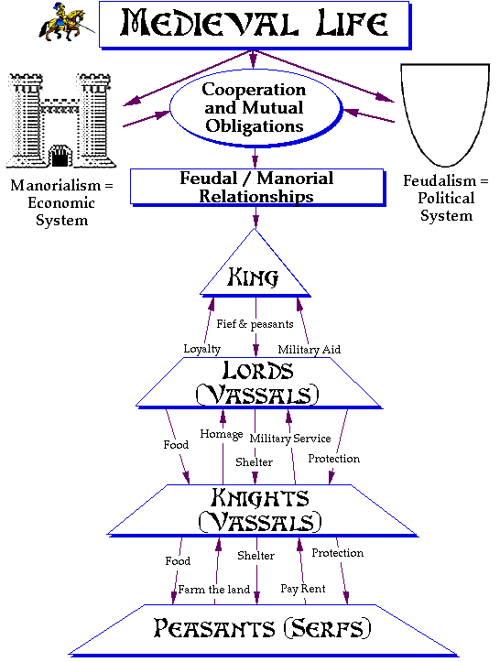

Political Developments
Feudalism prevailed. ______________________ authority meant that lords and vassals ruled locally through _______________________________________________________ to the upper lords and king.
The _______________________________________ was single strongest unifying factor across Western Europe during this period.
Economic Developments
__________________________________________ system prevailed . Serfs were _________________ to give a percentage of their ______________ to the lord in exchange for a plot of _________________________________.
Manors operated as ________________________________________ and a lack of food surpluses resulted in most of the population being _____________________________________.
Cultural Developments
Nobility _____________________________ determined one’s social status. In the upper classes, ___________________ was key to political power, Honor, loyalty, and duty were stressed under the knight’s code of _________________________. Religious and moral authority rested in the hands of the Catholic Church and the Pope.
Decentralized States
Japan, c. 600-1000
Geography: _____________________________________ of Japan led to the development of isolated communities,
Political Developments: Attempts at ____________________________ the Japanese state were relatively unsuccessful during the _____________________________. The Japanese also attempted to fashion their bureaucracy in the image of the ______________________________ model. Emissaries and scholars were sent to China.
Economic Development:
Japan was a ______________________________ society with a local artisan class of weavers, carpenters, and iron workers. Most people worked on land that was owned by other people and had to pay a _____ on their harvests on a yearly basis.
The Rise of Feudalism:
Eventually a system of ____________________ developed in which a central figure, the _________________, reigned as supreme military general and _____________________________authority over Japan. The power of the shogun was depended on the__________________________________________.
Cultural Developments:
The traditional Japanese religion is ______________________. According to Shinto beliefs, everything in nature ____________________________________ and natural forces ________________ the earth. Later, traditional Japanese customs combined with __________________________________
Contacts with China were halted during the Heian Period (794-1185) as the Japanese were encouraged to express traditional Japanese culture.
Women dominated literature during this period. The Tale of Genji was written by Lady Murasaki. Women enjoyed considerable legal and economic rights as compared to later periods.

Nomadic Empires
Nomadic Empires: The Vikings (c. 800-1100)
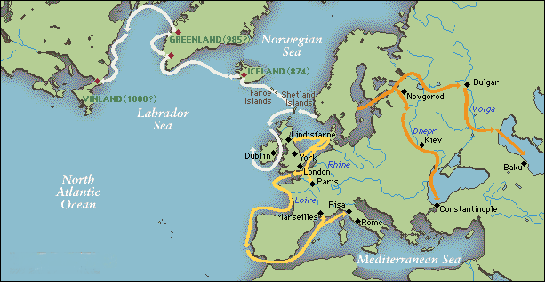
Nomadic group from Scandinavia
Conducted seasonal raids to supplement farm production
Ransacked towns and villages across Europe
Use of small maneuverable boats combined with ruthlessness in battle facilitated their success.
Nomadic Empires: The Vikings 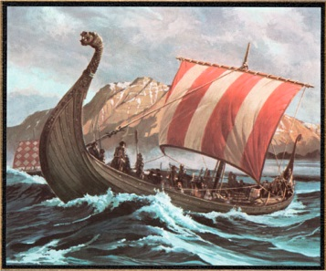
Explored north Atlantic Ocean, including Iceland, Greenland, Newfoundland Canada, and Northeast coast of United States (c. 1000).
Established settlements in Scotland, Northern France, and Eastern Europe.
Overtime, the Vikings adopted Christianity and were absorbed into the larger European feudal order (William the Conqueror).
Nomadic Empires: The Turks, c. 1000-1450
The Seljuk and Ottoman Turks 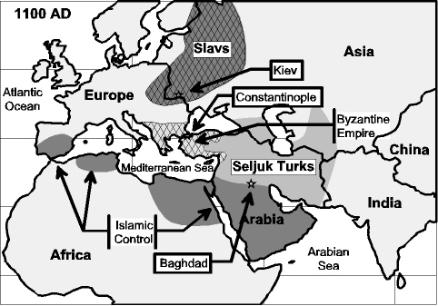
Pastoral nomadic group from central Asian steppes.
Often hired by Muslim leaders as mercenaries.
The Seljuk Turks invaded Baghdad in 1055 and took over the Abbasid Caliphate. By 1071, they were able to push the Byzantine Empire out of most of Anatolia.
Nomadic Empires: The Turks, c. 1000-1450
The Delhi Sultanate (afghan turks) 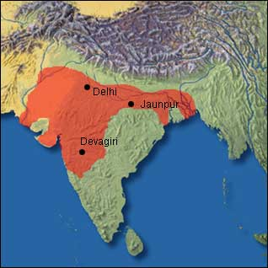
Began series of raids into India in the 10th century.
Gold, Jewels, and destruction of Hindu temples.
By the late12th century, the Afghan Turks settled in northern India and began the Delhi Sultanate which lasted from 1206-1526.-
Nomadic Empires: The Mongols, 1200-1550
Pastoral Nomadic Group of the Asian Steppe
Genghis Khan united the tribes of the steppe under the Mongol banner.
Horsemanship, archery, terror, and military strategy are keys to the Mongols quick rise to power.
Established the largest continual land empire in history.
GREATEST STRENGTH: Mobility via horses and mandatory military conscription of all men during times of war (ages 15-70).
Nomadic Empires: The Mongols, 1200-1550
Before his death, Genghis Khan divided his empire into administrative states called Khanates to be ruled by his sons and their descendants.
China: The Yuan Dynasty
Established by Kublai Khan who defeated the Song Dynasty.
Established centralized rule via the use of Persian bureaucrats.
Confucianism outlawed, civil service eliminated.
Chinese were segregated from Mongol population.
The Middle East: The Ilkhantes
Mongols in Middle East employed local bureaucrats and converted to Islam by 1295.
Local rulers kept in place as long as sufficient tax revenues were delivered to Mongol authorities.
Westward expansion into Africa was stopped in 1260 when they were halted by the Mamluks of Egypt.
Russia: The Golden Horde
Like their counterparts in the Middle East, the Mongol conquerors kept many of the local Russian rulers in place. Taxes on peasants were heavy, but they were collected by Russian bureaucrats. Trade was also supported.
The Pax Mongolia: The Mongol Peace
For a century, the continent of Asia was united under Mongol rule resulting in peace and an increase in trade and cultural interaction. The downside of this “peace” is debatable in terms of the total human cost.
Mongol Decline
Despite great military accomplishments the Mongol Empire only lasted three to four generations. They were great conquerors, but horrible administrators. Overexpansion (as seen in the failed invasion of Japan), poor governance, over spending and rivalries among Mongol leaders were the key factors in the decline of the Mongols. By 1350, most Mongol territories had been conquered by other armies.

